AST101: Our Place in the Universe

Lab 3: Measuring Distance

Version for Groups Meeting Online

*(Your group should import this document as a shared document into either Microsoft Office365 or Google Docs. Then your whole group should edit it together. If one member of your group is not present, list their name and write “absent” beside it.)*

|  |  |  |  |
| --- | --- | --- | --- |
| **Group Number and Name:** | |  | |
| **Member Name #1:** |  | **Email #1:** |  |
| **Member Name #2:** |  | **Email #2:** |  |
| **Member Name #3:** |  | **Email #3:** |  |
| **Member Name #4:** |  | **Email #4:** |  |
| **Lab Time and Date:** |  | | |
| **Collaboration Method (in-person, online on Collaborate, etc.)** |  | | |

*If someone in your group does not show up and did not tell you why, write “unexpected absence” by their name. If someone does not show up and has a good reason, write “expected absence” by their name, and describe what happened below.*

|  |
| --- |
|  |

**Overview**

We know the stars are very far away. But how far?

One of the issues that led to the development of the celestial sphere model was the observation that stars do not exhibit parallax; that is, to the naked eye, the position of stars relative to one another never appear to shift in even the slightest. If the stars are not all the same distance away, then they ought to at times appear closer together or farther apart. This lab will explore the concept of parallax, use it to measure the distances to objects, and end with the realization that even though the stars are different distances away, we could never measure this without access to telescopes.

**Materials**

For this lab, you will need:

* A camera (probably the one on your smartphone)
* A ruler; if you don’t have one, you can use a piece of lined paper
* A device with a larger screen, like a laptop
* A way to easily send pictures to your groupmates (over text message, email, etc.)

It will work best if you are able to go outside for part of it.

|  |
| --- |
|  |

**Prelude: What is Parallax?**

*Parallax* is the apparent shift in position of a *close* object, as seen against a *distant* background, when the position of the observer moves.

< Show two images >

< Show ray diagram >

This is the method that our eyes use to determine how far away things are. Here, instead of changing the position of the observer, our eyes provide us two ‘observers’ at the same time.

Hold your index finger out in front of your face, directly in front of your nose, and close your left eye, leaving your right eye open.

As you look at your index finger, its image will overlap with something in the background. Make a note of what that object is.

Then, close your right eye and look through your left eye, but don’t move your finger. Now, note what object in the background the image of your finger overlaps with.

Here, you moved your observing position (the eye that you have open) to the left. Did the spot in the background move left or move right?

|  |
| --- |
|  |

This shift is parallax.

Now, repeat this procedure again -- looking at your finger with one eye, and then the other, and seeing where it lines up with the background. However, this time, hold your finger out at arm’s length.

Did you observe more parallax, or less? *(In other words, did your finger jump further relative to the background, or less far?)*

|  |
| --- |
|  |

**Determining Distance with Parallax**

You’ve seen that parallax can be used to determine the distance away that something is, since you saw that the parallax exhibited by your finger depended on how far it was from your eyes.

This technique can be used to determine the distance to *any* object, if:

* you can look at that object
* … from two points that are far enough apart from each other
* … and compare that object to a background that is much further away than it is.

We can use this technique to look at *stars* and determine their distances; the background is stars that are even further away.

In order to use parallax to calculate the distances to objects, we need to first talk about how to quantify the amount of parallax that you see. The main idea here is that **the amount of parallax shown by an object between two observing points is an *angle*, not a distance.**

The figure below shows a diagram of parallax, with distances labeled; this should remind you of something from high school geometry class! But don’t worry -- you won’t need to do any trigonometry here.

* **B** represents the distance between the two observing points, called the *baseline*: this is something you can measure, since you’re the observer!
* **D** represents the distance to the object: this is what you want to find!
* 𝜃 represents the parallax angle: this is also something you can measure!

These things are related by a simple formula. When the angle 𝜃 is measured in degrees[1]:

So, if you know the distance between the observing points and the parallax angle, you can find the distance to the object.

The key here is that parallax is an *angle*. So, we need some way of measuring angles in the scenes that we see. For instance, we’ve said before that Polaris is 43 degrees above the horizon in Syracuse. But what does that mean -- and how do we measure it from a photograph?

**Angle of View**

Take out your cellphone and take a picture of a scene in front of you, holding the camera horizontal. Make a note of the leftmost object you can see and the rightmost object you can see.

Then, point with your left arm toward the leftmost object that is in the picture, and with your right arm toward the rightmost object in the picture. The angle between your two arms is the *angle of view* of the camera.

Each group member should do this separately. Estimate the angles of view of each of your cellphone cameras. Most cellphone cameras have an angle of view (across the long axis of the picture) of around 70 degrees; use this for the rest of this lab.

**Practice: Determining Angular Separation from a Picture**

Take a picture with your cellphone held horizontally. It doesn’t matter what it’s a picture of. Insert it into this document below.

Then, choose two objects in the picture. You will determine the angular separation between these objects. The procedure is simple:

$Angular separation in degrees = total field of view in degrees ×fraction of frame between objects$

The fraction of the frame between the objects, in turn, is the ratio between the distance between the objects and the total distance across the picture. This gives us:

$Angular separation in degrees = \frac{total field of view in degrees ×distance between objects}{total size of picture}$

You should display the picture on your computer screen and measure it with your ruler, or using the lines on a piece of paper. If you import it into your word processor, you can also use the ruler built into it.

Here’s an example. We’ll use this adorable picture of Toby the Cat, and measure the angular distance between her ears.



Here’s a screenshot of what I see in Google Docs, as I am writing this:

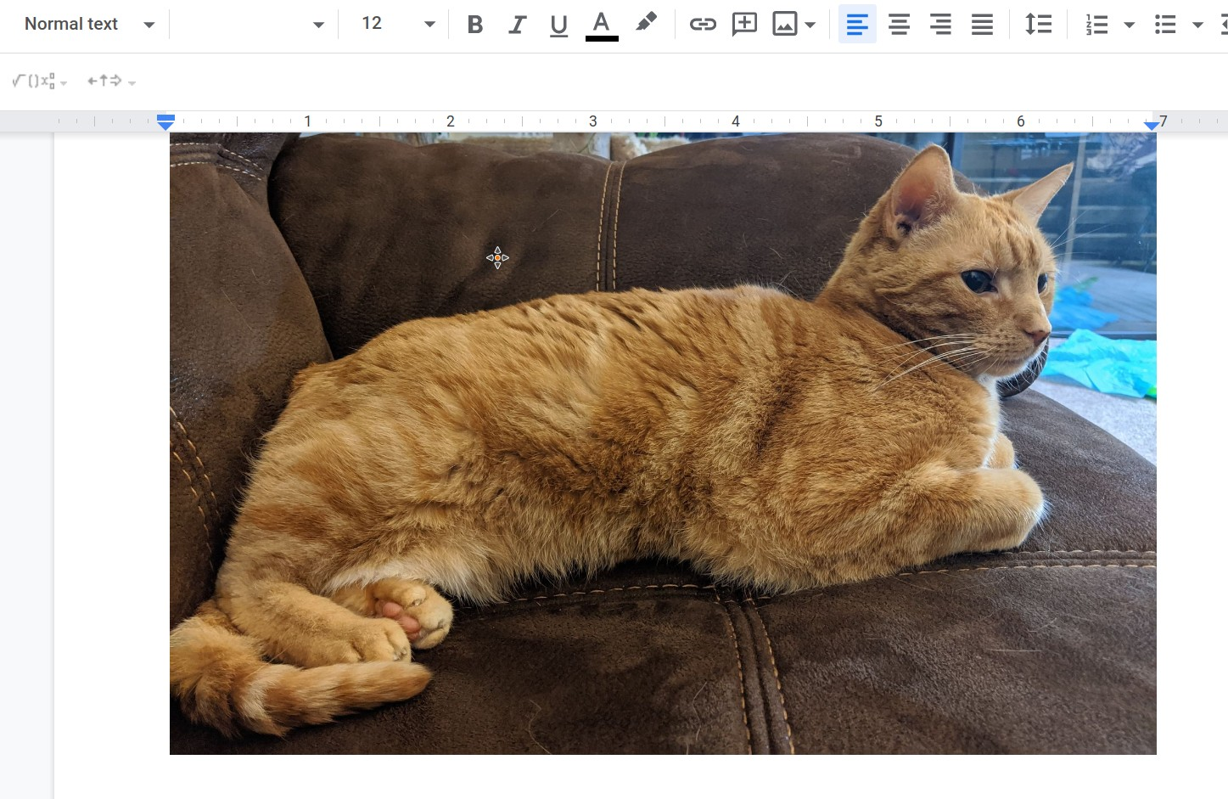

When I look at this picture, I see that the whole picture is 7 inches wide, and that Toby’s ears go from 5⅜ inch to 6⅜ inch on the ruler. This means that -- *in this document* -- Toby’s ears are one inch apart.

My cellphone camera has an angle of view of around 70 degrees. Recall the formula from before:

$Angular separation in degrees = \frac{total field of view in degrees ×distance between objects}{total size of picture}$

This means that to calculate the angular separation between Toby’s ears:

$Angular separation in degrees = \frac{70 degrees ×1 inch}{7 inches}= 10 degrees$

Do a similar calculation with two objects in your own picture. Insert your picture below:

What two objects in your picture are you looking at?

|  |
| --- |
|  |

What is the total width of your picture (according to your computer’s ruler)?

|  |
| --- |
|  |

What is the distance between the two objects in your picture (again, according to your computer’s ruler)?

|  |
| --- |
|  |

Using the formula from above, what is the angular separation between the two objects in degrees?

|  |
| --- |
|  |

Now, you’re ready to use parallax to determine the distance to a distant object that you can see against a background. That object should be 10 to 50 meters away from you. (Light-posts and isolated trees work very well for this. If you are doing this by Holden, use one of the light posts.)

Only one person in the group needs to take the two pictures: the other folks should help them make the calculation.

For the baseline, we’ll use the distance between your arms. For most people, this distance is nearly equal to their height. Hold your cellphone horizontally in your left arm and take a picture; then, hold your cellphone horizontally in your right arm and take a picture. Insert your two images into this document below.

What object are you going to measure the distance to?

|  |
| --- |
|  |

Look at the two pictures and see where your object lines up with the background.

As an example, here are two of mine:

<example image 1> <example image 2>

(In the right image, I’ve marked the spot where the lightpost was in the left image.)

Using the technique you practiced earlier, determine the angular separation between these two points in the background -- the parallax angle. How many degrees is that?

|  |
| --- |
|  |

How far apart were these two pictures taken? (This is their height. If they only know their height in American units, convert to meters.)

|  |
| --- |
|  |

Recall the formula above:

$D = \frac{\{57 B\}}{θ}$

Since you now know the baseline distance B and the parallax angle 𝜃, you can calculate the distance to your object (your lamppost). How far away is it?

|  |
| --- |
|  |

Is your result reasonable or not?

Scientists are frequently concerned with *accuracy* in measurements. During this process, there were several steps that you took that could result in slight inaccuracies in your result. For instance, if the separation between the two places where you took the pictures (the baseline) is 10% different from your height, then your result for the distance will be off by 10%. Discuss with your group: what are some of the other things that could make your result slightly inaccurate?

|  |
| --- |
|  |

**Application to Astronomy: Distance to the Stars**

Astronomers have known for a long time that parallax could be used to determine the distance to the stars -- if they are not too far away. (Remember, the parallax gets smaller as the distance increases.)

The technique is the same: take two pictures of the stars from different positions, determine the parallax angle, and calculate the distance.

Before rocketry, any observation of the stars had to be made from Earth. If you’re confined to Earth and wish to observe the parallax of stars, what is the longest baseline you can possibly have? *(Hint: Consider how Earth moves on its own.)*

|  |
| --- |
|  |

The diameter of the Earth’s orbit is 2 AU (Do you remember what an AU is?), and the closest star system to Earth other than the Sun is Alpha Centauri, approximately 300,000 AU away. Using the familiar equation from above, calculate the parallax angle that this star exhibits using the longest possible baseline available to us on Earth.

That equation from before is $D = \frac{\{57 × B\}}{θ}$. You will need to do a little algebra to solve for 𝜃.

How many degrees of parallax would Alpha Centauri exhibit?

|  |
| --- |
|  |

The most precise measurements of the positions of stars made without telescopes were done by Tycho Brahe, who measured their positions with a precision of 0.03 degree. Could Tycho have observed this parallax?

|  |
| --- |
|  |

*When you are done with your lab, make sure your document is still set to the sharing option “Anyone with the link can view”. Then email a link to your shared document to* [*suast101labs@gmail.com*](mailto:suast101labs@gmail.com)*. The subject line in your email should be “Lab 2 – Group #### – <your names>”.*

1. The formula is just “D = B / 𝜃” when the angle is measured in radians; the funny factor of 57 converts radians to degrees. If you don’t know what a radian is, ignore this footnote!